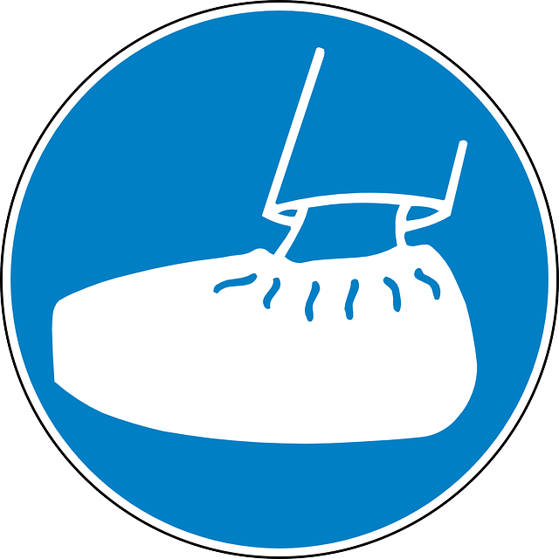
BOOTIES REQUIRED BEYOND THIS POINT

